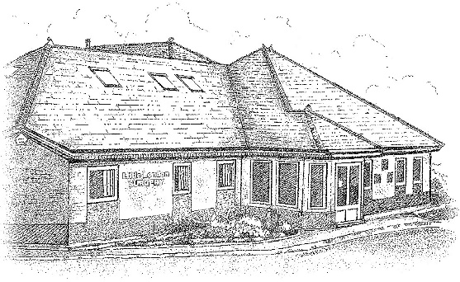

DR K OKUNRIBIDO, DR M MYAT,

DR M CHANDER AND DR R AHMED

LITTLE LONDON SURGERY PATIENT PARTICIPATION GROUP
THURSDAY 18TH JULY 2019 1.30-2.30PM –LUNCH PROVIDED
Apologies for Absence
TERENCE SHARP

IN ATTENDANCE
DR M CHANDER - GP
JODIE HOWELLS – SUPERVISER
GAYNA TAPPER – SECRETARY
JOHN PAGETT – PPG MEMBER
CHRIS PAGETT - PPG MEMBER
MALCOLM NEWPORT – PPG CHAIR
FIONA LEES – PPG MEMBER
ROBERT LIPKE – PPG MEMBER
DIANE MCLEAN – PPG MEMBER

Mr Newport appointed Chair for the meeting by Committee.
Mr Newport welcomed everyone to the meeting.

SELF CARE
Discussion on awareness of self-care. OTC (over the counter medicines).
CCG has implemented a scheme for over 16 year olds named OTC which is widely used to describe the items patients can purchase without a prescription to treat minor illnesses or conditions which are available from pharmacies, supermarkets, petrol stations. In the year prior to June 2017 £569 million was spent prescriptions for medicines which could be bought OTC from a pharmacy supermarket or petrol station rather than the GP.
Little London are making patients aware by displaying posters in the surgery. Discussion to further advertise on surgery announcement display in reception. Patients are not all aware that is it cheaper to buy medication OTC than obtains prescriptions sometimes. Every £1 million saved on prescriptions for OTC treatments could fund approximately 39 more community nurses or 270 more hip replacements or 66 more drug treatment courses for breast cancer or 1000 more medicine courses for Alzheimer’s or 1040 more cataract operations. MC stated an example of a patient recently who consulted for antifungal treatment costing £9 on prescription but only £3 OTC.
MC informs there are still too many patients consulting for minor illnesses (sore throats, diarrhoea, head lice, dandruff, nappy rash, hay fever etc) and is trying to promote self-care . Informed PPG members that our website gives detailed information on self-care. MC also suggests implementing leaflets for patients in reception to help awareness. Information available on Self Care Forum and NHS advice, Community pharmacies and leaflets from CCG self-care website.
Noted that patients can use opticians for minor eye problems rather than see GP - opticians more qualified in this field.

This scheme is only available face to face and patients do need to be seen and this is not a service over the telephone.
PPG member points out elderly patients mostly do not have access to computers thus would not have easy access to the scheme. MC responds that generally the elderly do not consult for minor illnesses and more so the younger generation.
PPG member asks if we could implement a ‘flagging system’ so patients that are elderly or unable to obtain self-care information be informed when they contact surgery.
MC states most pharmacies are aware of the patients who self-care and will not treat patients if they feel treatment is a high risk.
PPG members discuss repeat medication issues and often wrong causing undue stress to patients when delivery is incorrect. When medications finish at different dates / different quantities. MC states GPs can bring medications in line if patients can let us know. Consultants changing medications and adding medications when on other medication that’s contra-indicated causes medication prescribing issues. GPs do go through patient medication lists and stop any medications if they can.
MC states not always is it correct to be on a whole range of medication – i.e. one patient known to him with heart issues refuses to have medication prescribed and he has remained well for a long time with no problems.
MC states GPS are doing 20 million more consultations nationally. MC discussed staff and hours, also having more senior GPs returning all the time.
PPG member asked if the surgery has a triage nurse. MC states no but we have a new advanced nurse practitioner (Yvonne Allen) who is qualified to treat minor illnesses. Yvonne is also a cardiac nurse and very experienced. Yvonne also helps with home visits. We also have another ANP, Sarah Davidson on a locum basis.

PCO
Discussion on signing up to the new PCO, primary care service which is being set up nationally. This service offers appointment sessions at Little London Surgery enabling patients from other surgeries come to Little London for treatment. This is a pre-arranged service. The surgery still runs extended hours.
Reception supervisor points out it is trial by error at the moment and is being trialed on different days to see which days suit the service best. This service is nurse led.
MC explains the surgery is allocated a budget and this is how the scheme is paid. The surgery would be unable to employ a locum for this scheme because it would use all the budget provided to surgery.
MC states the government is trying to push paramedics being prescribers.
Discussion on our pharmacist, Bal. PPG member states how pleased she is with our pharmacist and was very impressed with the accuracy of her service and with drug queries.
MC states Little London is offering more appointments than ever, far more than most surgeries.
Discussion on DNA patients hindering the system
Supervisor states surgery tries not to pre book appointments any longer than 4 weeks in advance because people do not attend. PPG member points out the difficulty getting through telephone lines to cancel appointments. Supervisor states patients can cancel on line to solve calling surgery if unable to get through.
PPG Members discuss difficulty logging out of online system. Another PPG member states to sign out, click on name on top of screen and a dropdown menu appears, click sign out.

NHS APP
NHS app is the way forward – discussion on how Patients can now download NHS app to type in symptoms and information is provided informing what could be causing the symptoms.
Supervisor informs PPG members if patients already have an online account they are not required to set up a new account. If patients do not have an existing account a verification process is required.
MC points out patients may find there are a lot more appointments on line. 25% of appointments have to be online including appointments for bloods, baby immunizations and asthma reviews. Flu jabs can be booked online.
PPG member enquired if reminders for flu jabs will be sent out – still to be discussed due to the late delivery of the vaccines last year causing disruption. MC points our pharmacies do flu jab.
Suggestion that the surgery could have an open day to involve the community of the new schemes – it was felt that not enough patients want to attend.
.
Any other business
Members asked if any positive comments on NHS choices website.

Date and Time of next meeting – 21ST NOVEMBER 1.00PM-2.00PM

