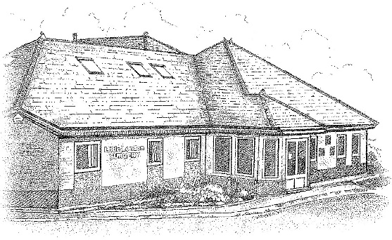

DR K OKUNRIBIDO, DR M MYAT,

DR M CHANDER AND DR R AHMED

LITTLE LONDON SURGERY PATIENT PARTICIPATION GROUP
THURSDAY 21st FEBRUARY 2019 2.00-3.00pm

Apologies for Absence

IN ATTENDANCE
Dr M Chander- GP
Jodie Howells – SUPERVISER
Sue Millward – SECRETARY
– PPG MEMBER
- PPG MEMBER
– PPG MEMBER
– PPG MEMBER
– PPG MEMBER
- PPG MEMBER
– PPG MEMBER

Mr N appointed Chair for the meeting by Committee.
Mr N welcomed everyone to the meeting.

Health Watch Visit – how to engage with younger generation to join PPG
How could we engage with members of the community, to encourage more diversity in the group. Discussion as to whether a different time of day or day of the week to hold the meetings would be worth trying as 2-3pm clashes with school pick-up. However acknowledged would not want to lose the current members by making meetings inaccessible to them.
Mr P acknowledged that people will only want to engage if there is something on the agenda they wish to discuss.
Dr Chander said it might be that patients do not realise they have a say in the surgery. He has talked to many patients from all parts of the community to ask them to engage but has not been successful.
It was suggested that the issues for discussion as well as meeting times could be posted on social media.
Another suggestion was to invite students from local schools and other community groups to explain what the PPG is about.
Suggestion that the surgery could have an open day to involve the community and also the take part in the planning of the event.
Suggestion for a Little London Surgery Whatsapp group but this could prove difficult to manage.
Question raised as to what response was fed back regarding text message sent from surgery. These are no response message so difficult to know.

It was discussed that a PPG information leaflet/flyer could be created for the surgery and members could come in the surgery waiting room to talk to patients and inform them about the PPG and hand out the flyers. This was well received by all committee members.
NHS England Consultation of Medications that should not routinely be prescribed in general practice
Discussion on NHS England consultation on named medications they have recommended should not be prescribed. Dr Chander felt more appropriate for GPs to discuss. NHS England list read through by the group and comments agreed and noted by PPG committee.
New Secretary
Jodie said Gayna could not attend evenings, but can attend afternoons.
Practice Questionnaires
Is the group happy to come in and do questionnaires with patients. Most patients are willing to fill in the questionnaires. Members to let Jodie know if they are available between 9 and 11.30, Tuesdays or Fridays.
Recruitment of new Advanced Nurse Practitioner (ANP)
Sarah Davidson initially appointment on a trial basis on both sides, working Tuesday, Wednesday and Thursday to help with minor illnesses. ANPs quite difficult to find at the moment so glad to have her working here.
When patients phone for an appointment for a minor illness they will be directed towards ANP clinic. Sarah can prescribe. This frees up more time for the GPs to see other patients.
Also Dr Daniel Allen is a locum GP who works all day Mondays.
Jodie explained we now have 6-8 appointments available on each day which are 7 minute appointments for one acute problem, bookable with on the day with the duty doctor for the day.
Dr Chander explained GPs regularly see patients for more than one condition at each routine appointment in an attempt to save further appointments, for the convenience of the patient and for better patient care.
Any other business
Members asked if any positive comments on NHS choices website.
Primary care networks – Government encouraging surgery to work with 3-4 other surgeries in the area to form small hubs and opening weekends, pooling resources etc. The surgery is currently in negotiations to join a network and hopefully will be an improvement.
Does the surgery do any social prescribing? EG gardening etc prescribed for stress etc. Patients are referred to You Walsall which works with patients towards lifestyle changes.
Date and Time of next meeting to be arranged.

