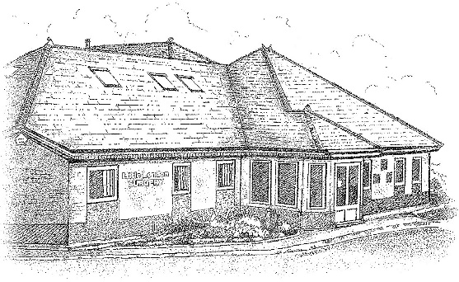

DR K OKUNRIBIDO, DR M MYAT,

DR M CHANDER AND DR R AHMED

LITTLE LONDON SURGERY PATIENT PARTICIPATION GROUP
THURSDAY 18 8 22
Apologies for Absence
XXXXXXXX
XXXXXXXX
XXXXXXXX

IN ATTENDANCE
DR M CHANDER - GP
GAYNA TAPPER – SECRETARY
JODIE HOWELLS – RECEPTION SUPERVISOR
XXXXX
XXXXX
XXXXX
XXXXX
XXXXX
XXXXX

MC opened meeting, welcomed all members.
MN – main item is patient survey. We are above national average.
MN attends PPLG and if there is anything relevant to be raised from the meetings Mr Newport will reiterate to our group relevant things ie shared care records, changes in organisation. Slight change in emphasis in involvement nad trying to reach out to various groups ie disabled etc. anything MN receives from PPLG copies are forwarded to GT in case anything needs to be sent out to PPG members. MC states MN IS our main iliaison for this. The surgery also receives this. MC would like copies of this too.
MC WOULD rather surgery liaise with PPG MEMBERS FOR input on up-to-date meetings – GT happy to carry on doing this.

- EXTENDED ACCESS
Commencing October.
RA – PRIMARY CARE NETWORK 3-4 years ago there were different practices put together.
We are a group of 9 practice,. We have not joined and nobody has joined us it is just working together. Nothing is shared with anyone

DISCUSSED GP SURVEY
490 surveys sent out
115 returned
23% completion rate
Above is about average what we get back. Sent in post and pts are selected. Questions are changed each year. Patients can also complete online.
Good overall experience 73%
33% fairly good
40% very good
NATIONAL 72% - we were above the national and integrated care system.

MN very impressive as we are a relatively small practice compared to big medical centres. Who had scope to offer different services
MC we still are one of the largest practices in Walsall – approx. list 9,000 patients. Size is increasing.

Accessing practice – 64% good overall experience of making an appointment – please refer to survey.
MC states this is a national topic now since pandemic and reopening of services. There is huge backlog across the board. Some specialities closed down causing a knock on effect with waiting times i.e. dermatology 12 month wait. Patients keep returning to surgery but pts need consultants input.

We were open during whole pandemic. We offer face to face, tele consultations, e consultations and video consultations. Open Saturdays.
NHS app patients can obtain results – fill out a form at reception to have access to medical records.

GT we do use A&G to help while patients are awaiting appointments.

MC explains access can be difficult for surgery. We have fulltime ANP doing more hours and 2 new STD trainers who are nearly GPs – in final year of training. This offers more appts for patients. The trainees are free to go and discuss any queries with GPs as a safety net.

If patients are willing to wait all patients will get their choice of GP.

Easy to get through to GP practice by phone 40%.
We have 3 lines. We have tried other systems ie patients to send emails for acute illnesses vut has not taken off. This would free up lines it patients used other ways to contact surgery. Our surgery is a lto easier to get through to than other practices.

MN would be good to know where you are in queue so they know how long waiting

MC but it was costly. We have invested in new telephone service, which has taken 7 years to pay off £12,000.

Do we have an email for the surgery

JODIE we have not got an email for pts to contact for the surgery as unsure how to manage this. If all pts can use a surgery would be inundated

MC email that is open for acute prescriptions which is open for everyone has not been used.
Ie – if mc prescribed meds and needed an extra bit and was on acute but not long term he wouldn’t have to wait on phone he could send email in and mc would do this.

MN- younger generation have moved on to texts.

MC we have e consults and pts shouldn’t request repeat scripts on there but they do. With any system always pro’s and cons. E consult is for simple medical request but patient can ask for in-depth things and sick notes which is not used for.

Helpfulness of receptionists at practice 85% - MC states nice to know as above national average and has always been high score.

Satisfied with general practice appointment times available 66%. MC states it is the national contract.
There are appts on a Saturday with ANP and can have bloods, minor medical conditions.

Offered a choice of appointment when last tried to make a general practice appointment 61%.

Satisfied with appointments offered 83%.

Healthcare professional was good at giving enough time to patient 77%. We try to give everyone the time they
need. Some consultations are longer than others.

Healthcare professional was good at listening to patient 82% - very high score. Only just below national average.

Healthcare profession was good at treating patient with care and concern 83% reaching national average. High score.

Patient was involved as much as they wanted to be in decisions about their care and treatment 85% very high. Probably as high as you could get in this demographics. Discussion on interpreters - volunteers for interpreters but confidentiality issues would prevent this. Software solutions would solve language barriers.

Jodie – some patients do come with translation on their phones and when reception speaks the software translates back. MC Google translate can sometimes work.

MC if gp unsure of translation it is not safe to proceed in case misses medical history.

Patient had confidence and trust in the healthcare professions they saw or spoke to 89%

The patients’ needs were met 90%. GPs try their best but cannot always give patients what they demand.

Date and Time of next meeting to be arranged

